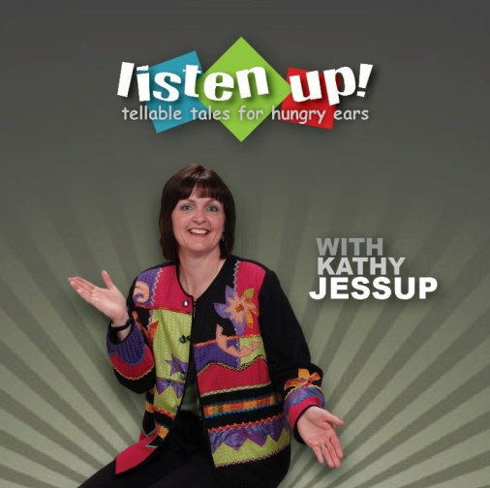
LISTEN UP! Tellable Tales for Hungry Ears
...is a collection of stories sure to entertain any captive audience. Be they bored kids stuck in a never ending car trip, families gathered around a campfire, or parents looking for ways to settle their children down for bedtime, LISTEN UP is definitely worth a listen!
The CD includes eight stories: seven written by Kathy, and one folktale from India. Most of the original works are “Hilary tales.” Kathy created the character Hilary years ago while raising three daughters. Over time, the story collection grew, with a never-ending supply of themes drawn from everyday life.
LISTEN UP was completed at the studios of Blackman Productions in south Edmonton. However, Kathy recorded two of her stories on location. The Grade Three class at Escuela Mill Creek School happily contributed sound effects and responses for the “live” recording, and the results are delightful.
As an added touch, Edmonton musician Colleen Moore-Kilgannon performs drum stings between the CD’s stories. Kathy’s intent is for the drumming to have a dual purpose: aside from serving as a break between stories, it also provides the stimulus for activity. Listeners are invited to follow along as Colleen beats out rhythms on the African Djembe and Irish Bodhran drums.
Recommended by the CANADIAN CHILDREN’S BOOK CENTRE guide BEST BOOKS FOR KIDS & TEENS 2010
CD PRICE: $16.00
AVAILABLE FROM:  http://www.cdbaby.com/cd/kathyjessup
  OR...directly from Kathy! Email her at: kathyjessup@hotmail.com

